ABBOTTABAD UNIVERSITY OF SCINECE AND TECHNOLOGY :

# :SYSTEM REQUIREMENT SPECIFICATION DOCUMENT:

# :NAME: MUHAMMAD ABDULLAH QAZI :

# :ROLL NUMBER : 14984 :

# :PROGRAM : BSSE :

# :SEMESTER : 4 {B}:

# :SUBJECT : SODTWARE CONSTRUCTION AND DEVELOPMENT:

# :SESSION : SPRING 2025 :

# :SUBMITTED TO : MAM SAMMAN SHAHEEN:

### 1. Introduction

#### 1.1 Purpose

This document defines the functional and non-functional requirements for the CLI-Based Task Manager System developed in C++.

#### 1.2 Scope

This is a command-line application that enables users to manage tasks with features like add, view, update, delete, mark as complete/incomplete, and filtering/search. Tasks are stored in files.

#### 1.3 Intended Audience

* Course Instructor
* Project Evaluator
* Future Developers
* Students for Learning Purposes

#### 1.4 Intended Use

Designed for educational use, showcasing modular development, file handling, and object-oriented programming in C++.

#### 1.5 Definitions and Acronyms

* **CLI**: Command Line Interface
* **CRUD**: Create, Read, Update, Delete
* **SCD**: Software Construction and Development

### 2. Overall Description

#### 2.1 Product Perspective

This is a standalone system developed in C++ using standard libraries and modular design.

#### 2.2 Product Functions

* Add/View/Update/Delete tasks
* Search tasks by ID or keyword
* Filter by status
* Save/load tasks using file I/O

#### 2.3 User Characteristics

Users should know how to operate a terminal and interact with CLI-based applications.

#### 2.4 Constraints

* Single-user system
* Local storage
* No graphical interface or networking

#### 2.5 Assumptions and Dependencies

* Valid inputs are provided
* C++ compiler is available
* File read/write permissions exist

### 3. Functional Requirements

**FR1: Add Task**  
User can add a task with title, description, and due date.

**FR2: View Tasks**  
Display all tasks with full details.

**FR3: Update Task**  
Update a task by entering its ID.

**FR4: Delete Task**  
Delete a task by entering its ID.

**FR5: Mark Task**  
Mark task as complete or incomplete.

**FR6: Filter Tasks**  
Filter tasks by status (completed/incomplete).

**FR7: Search Tasks**  
Search by keyword or task ID.

**FR8: Save/Load Tasks**  
Tasks are saved and loaded using file I/O.

### 4. Non-Functional Requirements

**NFR1: Usability**  
Clear CLI interface using text menus.

**NFR2: Reliability**  
Handles invalid input gracefully.

**NFR3: Maintainability**  
Code is modular for easy updates.

**NFR4: Portability**  
Runs on any OS with a standard C++ compiler.

### 5. System Modules

|  |  |
| --- | --- |
| main.cpp | Program entry and CLI menu |
| task.hpp / task.cpp | Task class and methods |
| file_manager.cpp | Handles file input/output |
| date_util.cpp | Validates and formats dates |
| search.cpp | Searching tasks by ID or keyword |
| filter.cpp | Filters based on completion status |
| ui.cpp | CLI prompts, input handling |
| test.cpp | Testing the core features |

### 6. User Interface

* CLI menu with numbered options
* Prompts and console feedback
* Input via cin, output via cout

### 7. Future Enhancements

* Add GUI with Qt or another library
* Add task prioritization
* Multi-user functionality
* Add deadline reminders

### 8. Class Diagram

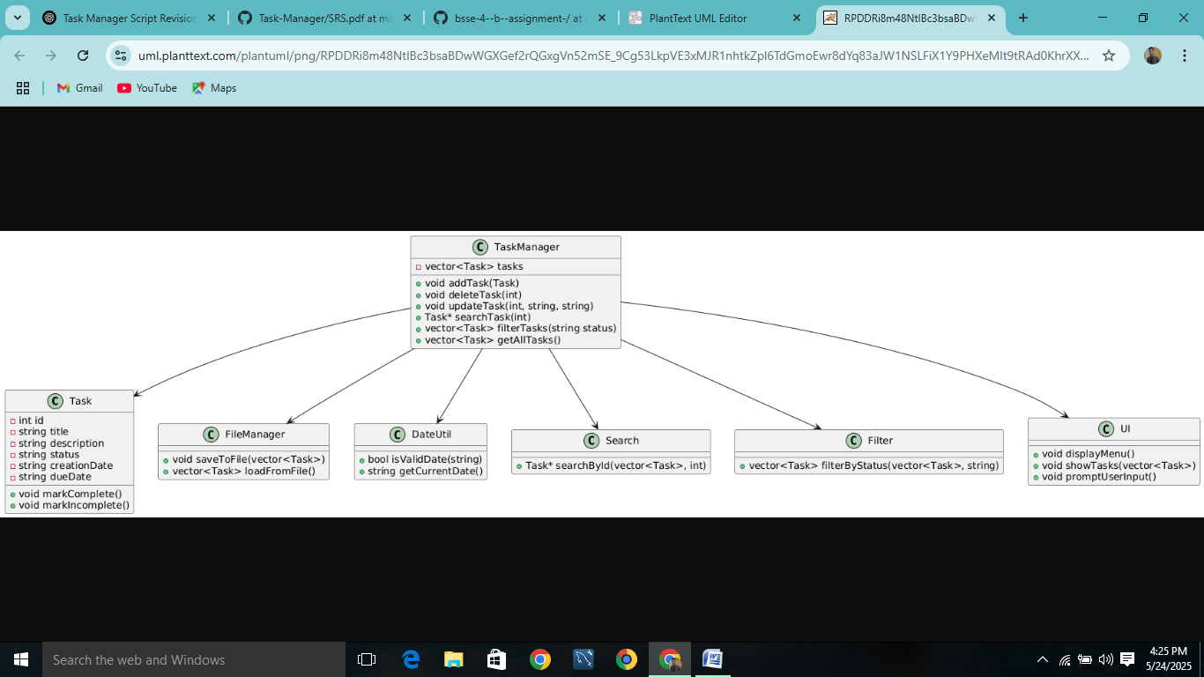

### 9. Use Case Diagram

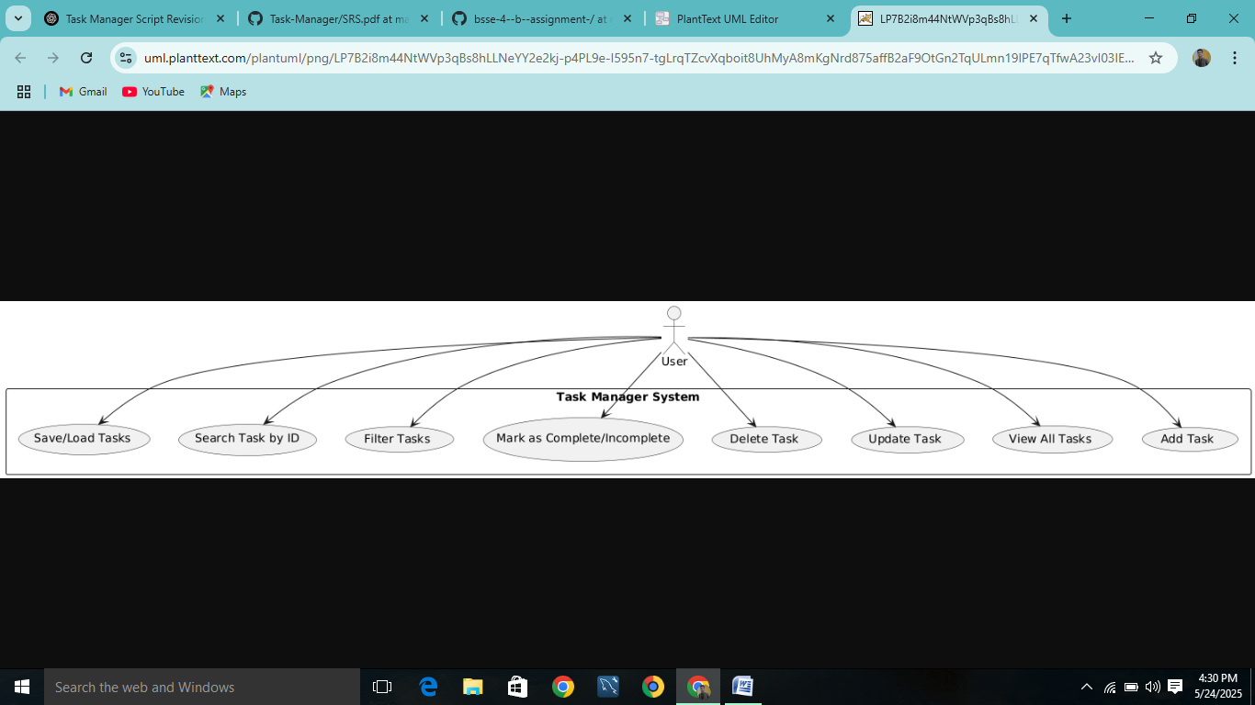

### 10. Appendix

#### 10.1 Development Tools

* Language: C++
* IDE: Code::Blocks / VSCode
* Compiler: g++

#### 10.2 File Structure

* .cpp and .hpp files in project root
* tasks.txt or equivalent for file storage